Build Your DB Server and Interact With Your DB Using an App
Task 1: Create a Security Group for the RDS DB Instance
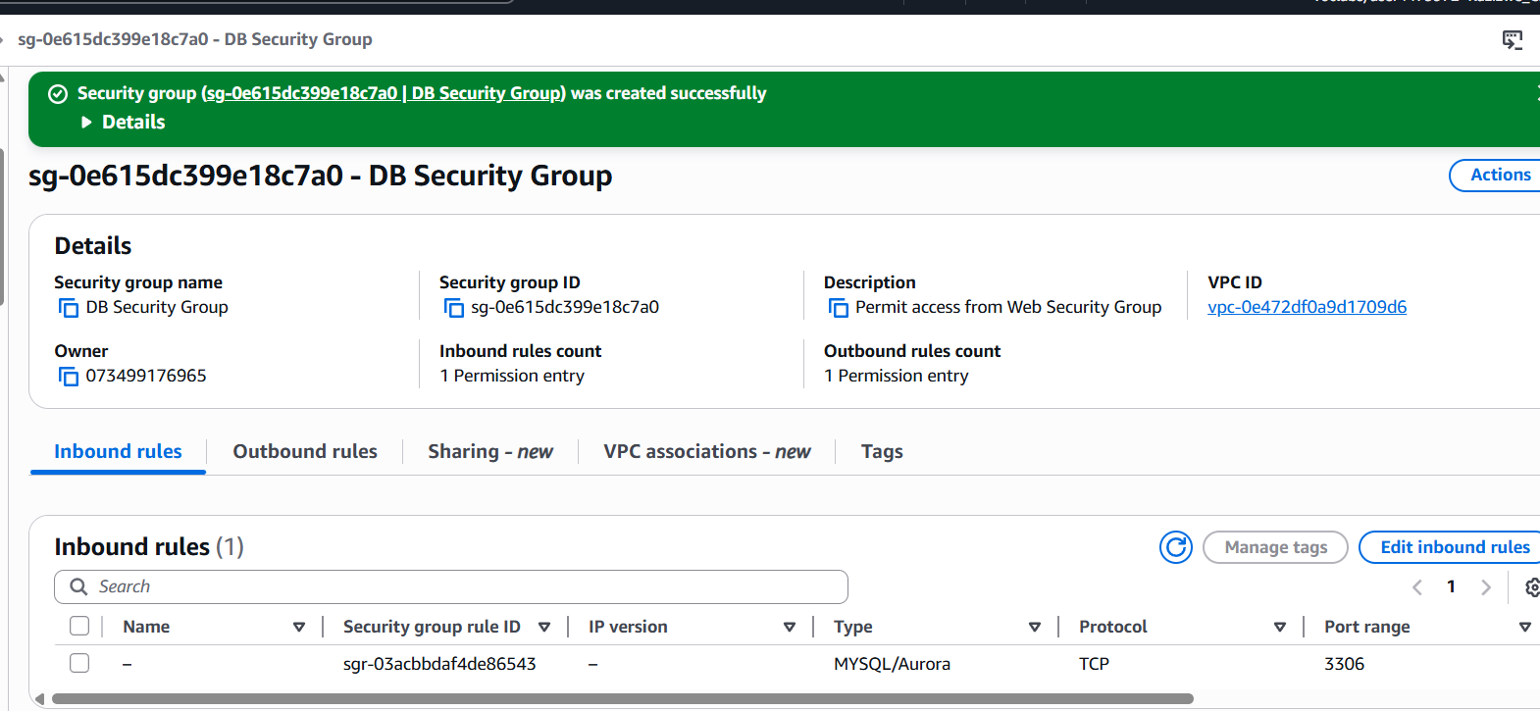
Task 2: Create a DB Subnet Group
Create a DB subnet group that is used to tell RDS which subnets can be used for the database.
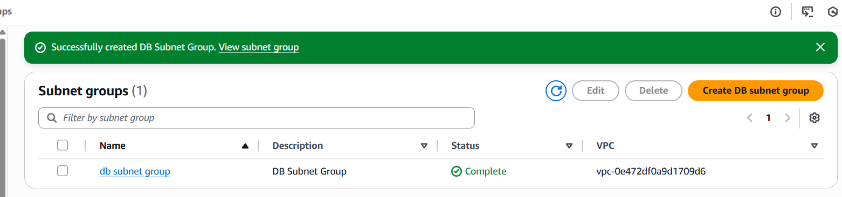
Task 3: Create an Amazon RDS DB Instance
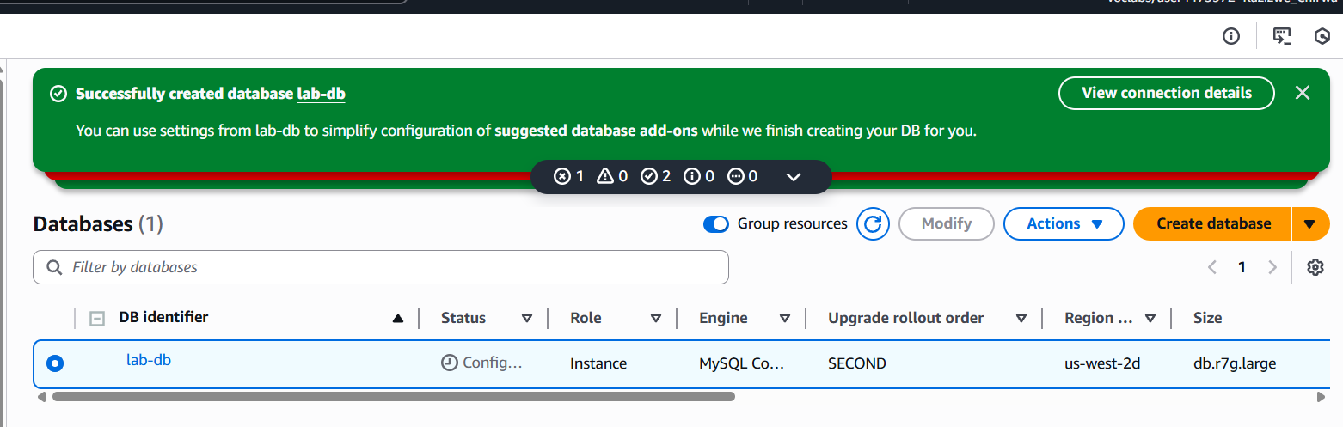
Task 4: Interact with Your Database

